APPLICATION

STUDENT TRUSTEE

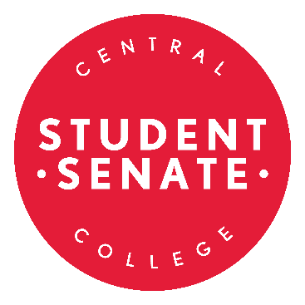
Five Central College students shall serve as Student Trustees, non-voting representatives to the Board of Trustees. The Student Body President serves as one, and the remaining four are open to the entire Central College student body. The role of Student Trustee is crucial in order to have the voice of the students present during important decision-making processes. Representatives should demonstrate leadership experience, dedication, commitment, and effective communication skills.

In order to run, the applicant must provide a 250-1000-word personal statement explaining his/her purpose and qualifications for seeking the position and a current resume. A letter of academic good standing from the Registrar should be submitted as well.

Please send in digital copies of your completed resume, essay, and letter to the Student Senate via email to hornerj1@central.edu OR rousea1@central.edu. If you have any questions contact the current Student Body President and co-chair of the Election Committee, Aiyana Rouse, (rousea1@central.edu).

Your completed application is due by 12:00 noon on Friday, March 5, 2021.

